Exercício 1

Fluxograma:

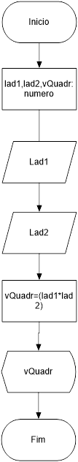

|  |  |
| --- | --- |
| TESTE DE MESA | |
| Lad1 | 5 |
| Lad2 | 5 |

|  |  |  |
| --- | --- | --- |
| MASSA DE DADOS | | |
| Lad1 | = | 5 |
| Lad2 | = | 5 |
| Vquadr | = | 25 |

Exercício 2

Fluxograma:

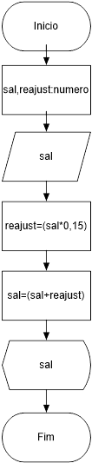

|  |  |
| --- | --- |
| TESTE DE MESA | |
| sal | 1500 |

|  |  |  |
| --- | --- | --- |
| MASSA DE DADOS | | |
| Sal | = | 1500 |
| Reajust | = | 225 |
| Sal | = | 1725 |

Exercício 3:

Fluxograma:

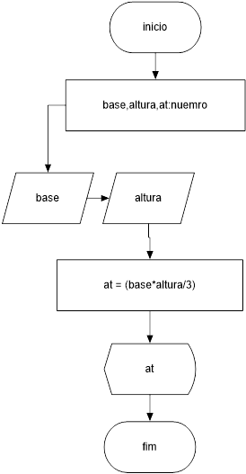

|  |  |
| --- | --- |
| TESTE DE MESA | |
| Base | 10 |
| altura | 5 |

|  |  |  |
| --- | --- | --- |
| MASSA DE DADOS | | |
| Base | = | 10 |
| Altura | = | 5 |
| at | = | 16 |

Exercício 4:

Fluxograma:

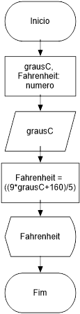

|  |  |
| --- | --- |
| TESTE DE MESA | |
| grausC | 10 |

|  |  |  |
| --- | --- | --- |
| MASSA DE DADOS | | |
| grausC | = | 32 |
| Fahrenheit | = | 89 |

Exercício 5:

Fluxograma:

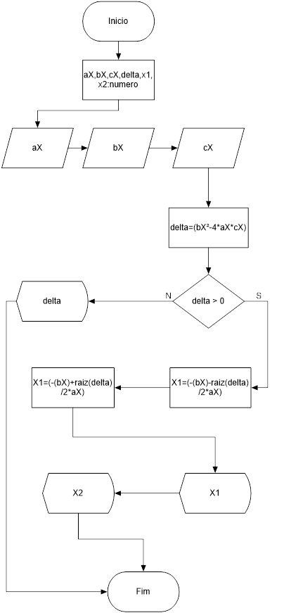

|  |  |  |
| --- | --- | --- |
| TESTE DE MESA | | |
| aX | 10 | 4 |
| bX | -4 | 8 |
| cX | -5 | 6 |

|  |  |  |  |
| --- | --- | --- | --- |
| MASSA DE DADOS | | | |
| aX | = | 10 | 4 |
| bX | = | -4 | 8 |
| cX | = | -5 | 6 |
| X1 | = | -1 | Delta é =<0 |
| X2 | = | 5 | Delta é =<0 |

Exercício 6:

Fluxograma:

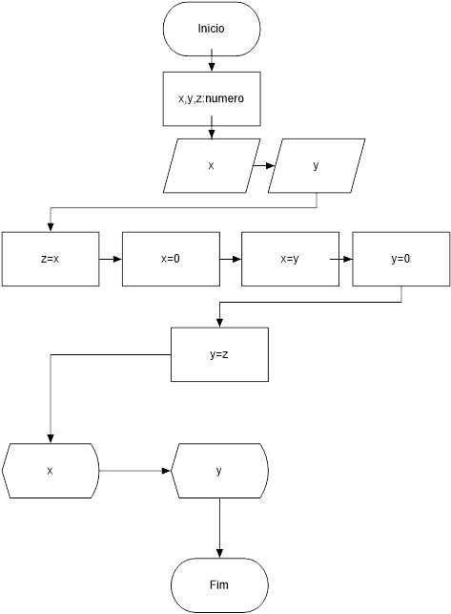

|  |  |
| --- | --- |
| TESTE DE MESA | |
| X | 7 |
| y | 2 |

|  |  |  |
| --- | --- | --- |
| MASSA DE DADOS | | |
| X | = | 2 |
| Y | = | 7 |

Exercício 7:

Fluxograma:

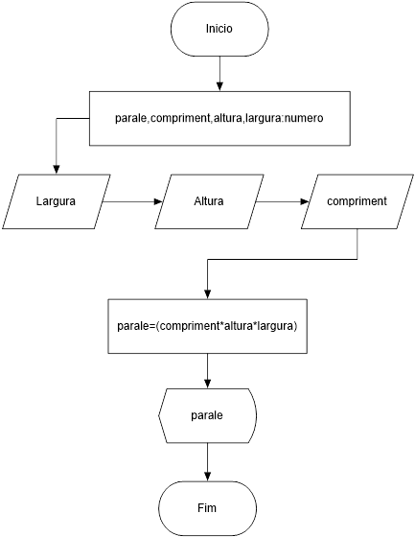

|  |  |
| --- | --- |
| TESTE DE MESA | |
| Largura | 20 |
| Altura | 40 |
| compriment | 2 |

|  |  |  |
| --- | --- | --- |
| MASSA DE DADOS | | |
| Largura | = | 20 |
| Altura | = | 40 |
| compriment | = | 2 |
| Parale | = | 1600m³ |

Exercício 8:

Fluxograma:

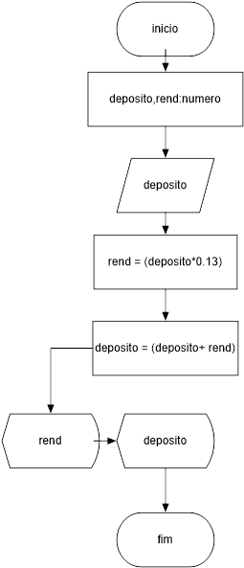

|  |  |
| --- | --- |
| TESTE DE MESA | |
| Deposito | 200 |

|  |  |  |
| --- | --- | --- |
| MASSA DE DADOS | | |
| Deposito | = | 200 |
| Rend | = | 26 |
| rendMes | = | 226 |

Exercício 9:

Fluxograma:

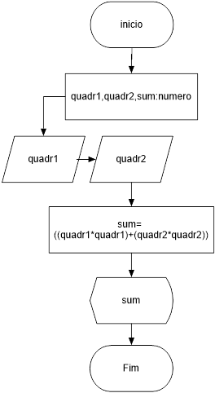

|  |  |
| --- | --- |
| TESTE DE MESA | |
| Quadr1 | 5 |
| Quadr2 | 5 |

|  |  |  |
| --- | --- | --- |
| MASSA DE DADOS | | |
| Quadr1 | = | 5 |
| Quadr2 | = | 5 |
| rendMes | = | 50 |

Exercício 10:

Fluxograma:

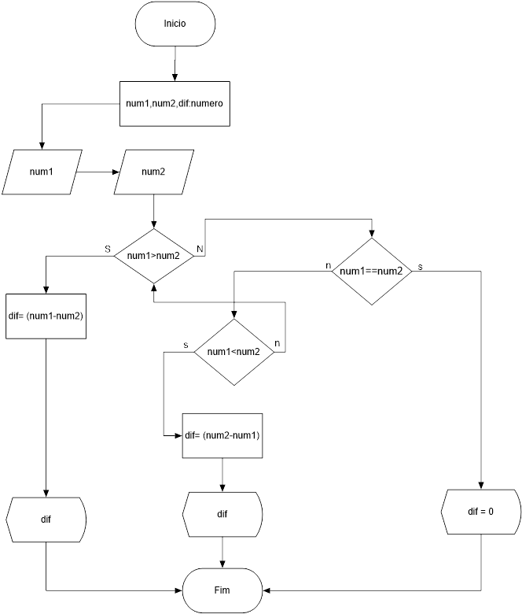

|  |  |  |  |
| --- | --- | --- | --- |
| TESTE DE MESA | | | |
| Quadr1 | 5 | 2 | 5 |
| Quadr2 | 3 | 5 | 5 |

|  |  |  |  |  |
| --- | --- | --- | --- | --- |
| MASSA DE DADOS | | | | |
| Quadr1 | = | 5 | 2 | 5 |
| Quadr2 | = | 5 | 5 | 5 |
| dif | = | 2 | 3 | 0 |

Exercício 11:

Fluxograma:

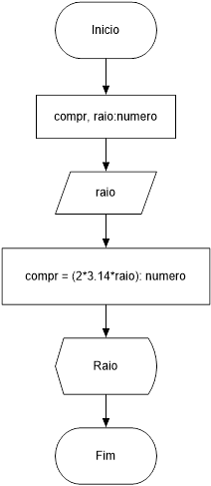

|  |  |
| --- | --- |
| TESTE DE MESA | |
| Raio | 36 |

|  |  |  |
| --- | --- | --- |
| MASSA DE DADOS | | |
| Raio | = | 36 |
| Compr | = | 226 |

Exercício 12:

Fluxograma:

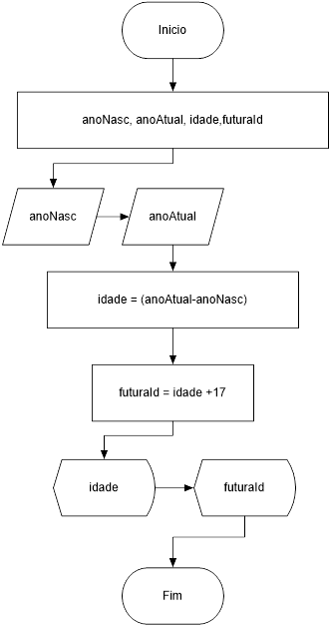

|  |  |
| --- | --- |
| TESTE DE MESA | |
| AnoNasc | 1997 |
| anoAtual | 2017 |

|  |  |  |
| --- | --- | --- |
| MASSA DE DADOS | | |
| AnoNasc | = | 1997 |
| anoAtual | = | 2017 |
| Idade | = | 20 |
| futuraId | = | 37 |

Exercício 13:

Fluxograma:

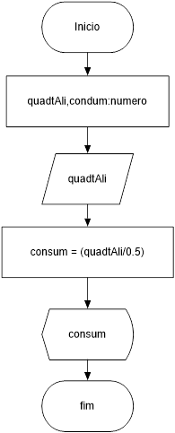

|  |  |
| --- | --- |
| TESTE DE MESA | |
| quadtAli | 7 |

|  |  |  |
| --- | --- | --- |
| MASSA DE DADOS | | |
| quadtAli | = | 7 |
| Consum | = | 14 |

Exercício 14:

Fluxograma:

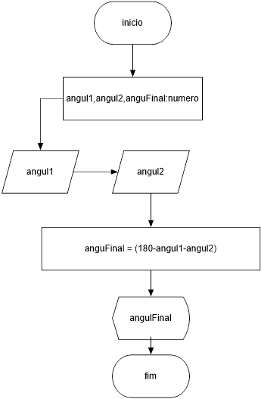

|  |  |
| --- | --- |
| TESTE DE MESA | |
| Angul1 | 50 |
| Angul2 | 7 |

|  |  |  |
| --- | --- | --- |
| MASSA DE DADOS | | |
| Angul1 | = | 36 |
| Angul2 | = | 226 |
| anguFinal | = | 123º |

Exercício 15:

Fluxograma:

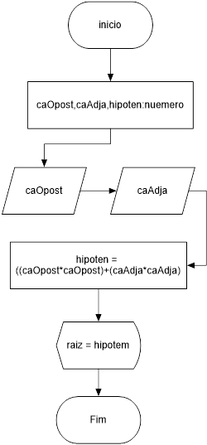

|  |  |
| --- | --- |
| TESTE DE MESA | |
| caOposto | 144 |
| caAdja | 40 |

|  |  |  |
| --- | --- | --- |
| MASSA DE DADOS | | |
| caOposto | = | 144 |
| caAdja | = | 40 |
| hipoten | = | 149.4 |

Exercício 16:

Fluxograma:

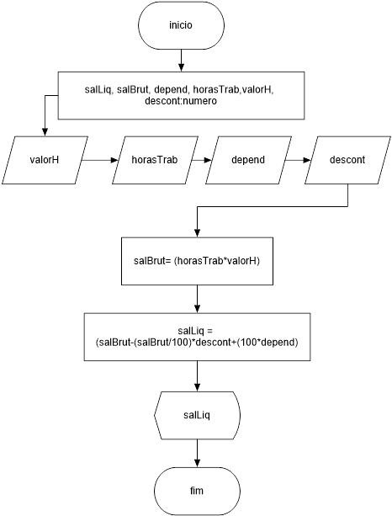

|  |  |
| --- | --- |
| TESTE DE MESA | |
| HT | 5 |
| QT | 10 |
| DP | 2 |
| Desc | 3 |

|  |  |  |
| --- | --- | --- |
| MASSA DE DADOS | | |
| HT | = | 5 |
| QT | = | 10 |
| DP | = | 2 |
| Desc | = | 3 |
| SalLiq | = | 250 |

Exercício 17:

Fluxograma:

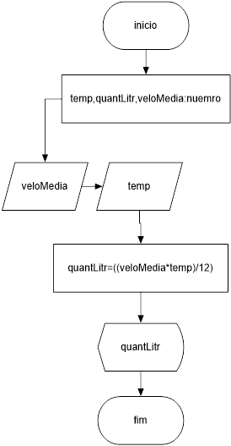

|  |  |
| --- | --- |
| TESTE DE MESA | |
| VeloMedia | 60 |
| Temp | 70 |

|  |  |  |
| --- | --- | --- |
| MASSA DE DADOS | | |
| VeloMedia | = | 60 |
| Temp | = | 70 |
| quantLitr | = | 350 |

Exercício 18



|  |  |  |  |
| --- | --- | --- | --- |
| TESTE DE MESA | | | |
| Números | 5 e 2 | 3 e 9 | 5 e 5 |

|  |  |  |
| --- | --- | --- |
| MASSA DE DADOS | | |
| 5 e 2 | = | 3 |
| 3 e 9 | = | 6 |
| 5 e 5 | = | 0 |

Exercício 19

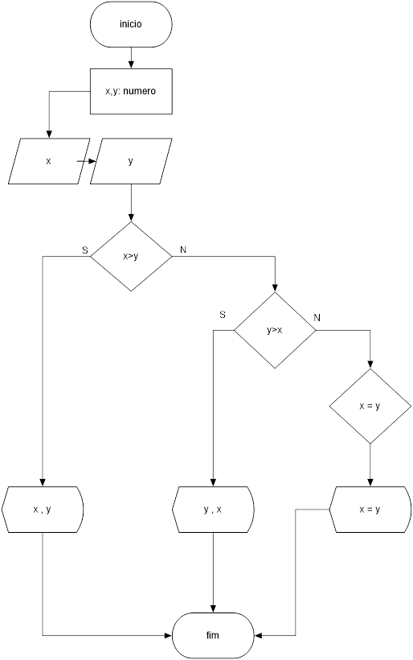

|  |  |  |  |
| --- | --- | --- | --- |
| TESTE DE MESA | | | |
| Números | 5 e 2 | 3 e 9 | 5 e 5 |

|  |  |  |
| --- | --- | --- |
| MASSA DE DADOS | | |
| 5 e 2 | = | 5 e 2 |
| 3 e 9 | = | 9 e 3 |
| 5 e 5 | = | 5 = 5 |

Exercício 20



|  |  |  |
| --- | --- | --- |
| TESTE DE MESA | | |
| Números | 1,-4,-5 | 4,8,6 |

|  |  |  |
| --- | --- | --- |
| MASSA DE DADOS | | |
|  | X1 | X2 |
| 1,-4,-5 | -10 | 5 |
| 4,8,6 | Indefinido | Indefinido |

Exercício 21

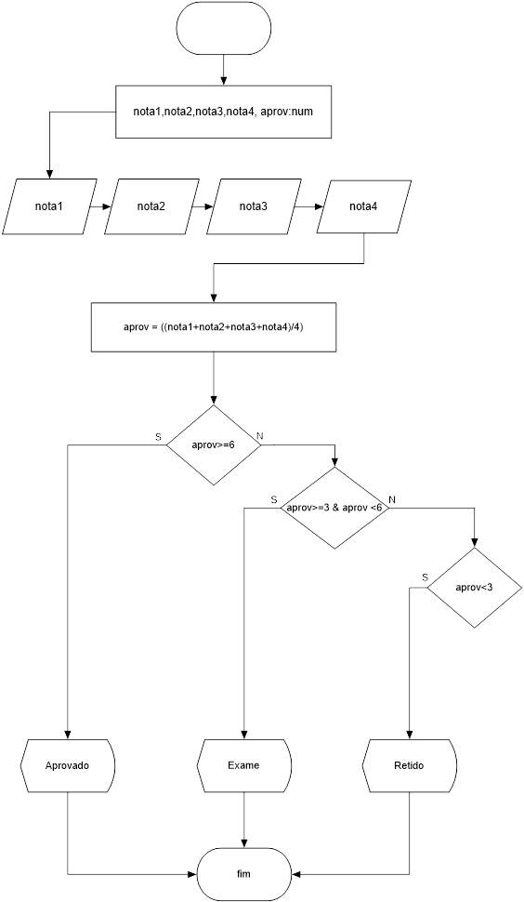

|  |  |  |  |
| --- | --- | --- | --- |
| TESTE DE MESA | | | |
| Notas | 7 | 4,5 | 5 e 5 |

|  |  |  |
| --- | --- | --- |
| MASSA DE DADOS | | |
| 7 | = | Aprovado |
| 4,5 | = | Exame |
| 2,2 | = | Retido |

Exercício 22

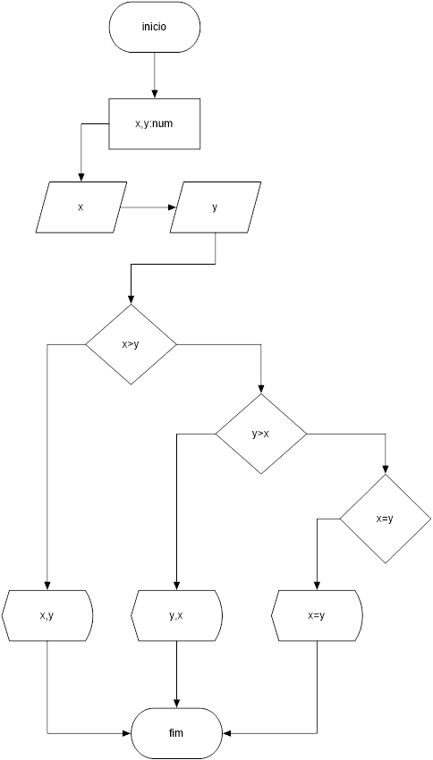

|  |  |  |  |
| --- | --- | --- | --- |
| TESTE DE MESA | | | |
| Notas | 5,2 | 4,5 | 5 e 5 |

|  |  |  |
| --- | --- | --- |
| MASSA DE DADOS | | |
| 5,2 | 5 | 2 |
| 2,9 | 9 | 2 |
| 5,5 | 5 | 5 |

Exercício 23

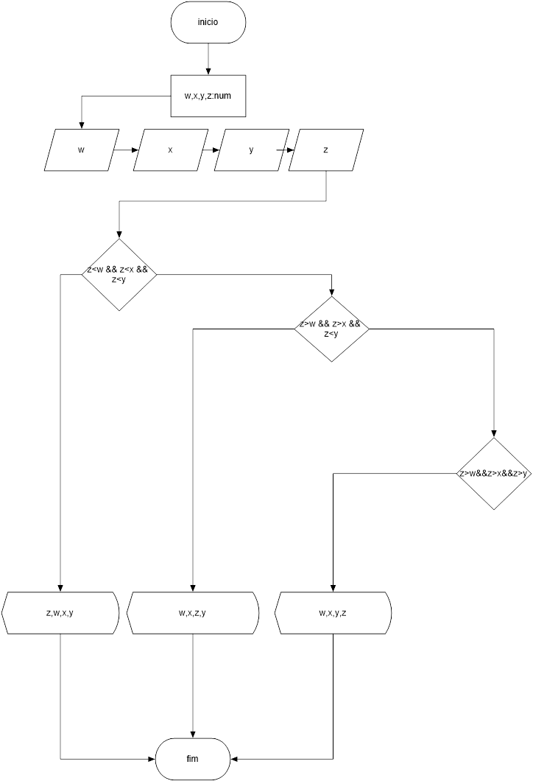

|  |  |  |  |  |
| --- | --- | --- | --- | --- |
| TESTE DE MESA | | | | |
| Posições | W | X | Y | Z |
|  | 2 | 3 | 4 | 1 |
|  | 1 | 2 | 3 | 4 |
|  | 1 | 2 | 3 | 6 |

|  |  |  |  |
| --- | --- | --- | --- |
| MASSA DE DADOS | | | |
| 1 | 2 | 3 | 4 |
| 1 | 2 | 3 | 4 |
| 1 | 2 | 3 | 6 |

Exercício 24

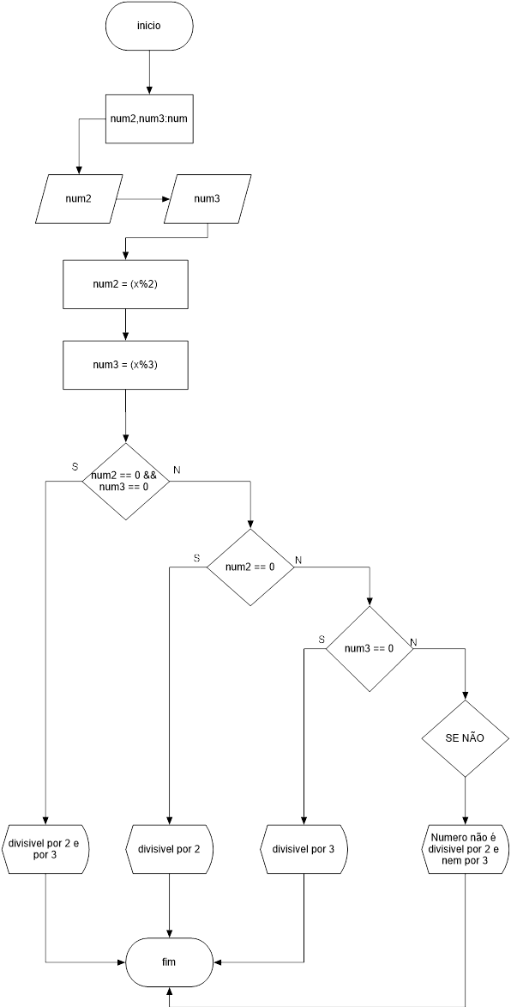

|  |  |  |  |  |
| --- | --- | --- | --- | --- |
| TESTE DE MESA | | | | |
| Números | 6 | 4 | 9 | 7 |

|  |  |  |
| --- | --- | --- |
| MASSA DE DADOS | | |
| 6 | = | É divisível por 2 e por 3 |
| 4 | = | É divisível por 2 |
| 9 | = | É divisível por 3 |
| 7 | = | Não é divisível por 2 e por 3 |

Exercício 25

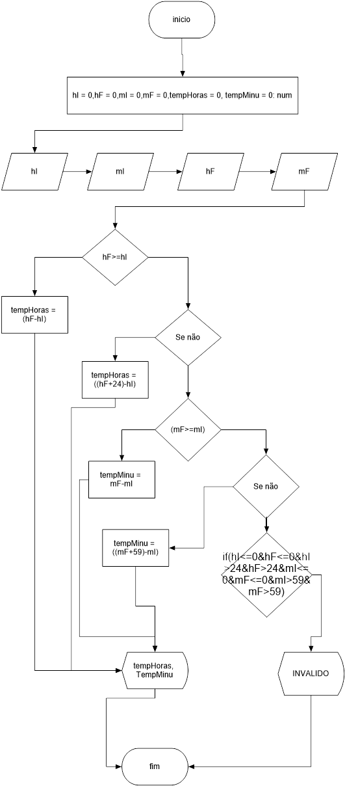

|  |  |  |  |
| --- | --- | --- | --- |
| TESTE DE MESA | | | |
| hI | 2 | 0 |  |
| mI | 20 | 0 |  |
| hF | 3 | 0 |  |
| mF | 50 | 0 |  |

|  |  |  |
| --- | --- | --- |
| MASSA DE DADOS | | |
| hI | 2 | 0 |
| mI | 20 | 0 |
| hF | 3 | 0 |
| mF | 50 | 0 |
| TempHoras | 1 | Invalido |
| TempMinutos | 30 | Invalido |

Exercício 26

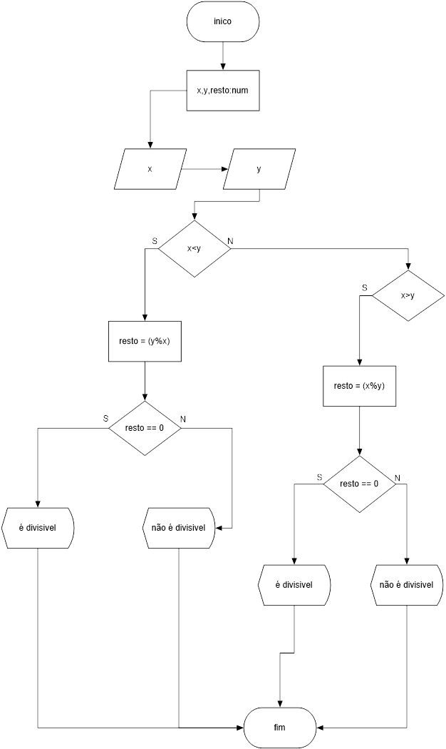

|  |  |  |  |
| --- | --- | --- | --- |
| TESTE DE MESA | | | |
| X | 10 | 5 |  |
| y | 2 | 2 |  |

|  |  |  |
| --- | --- | --- |
| MASSA DE DADOS | | |
| X | 10 | 5 |
| y | 2 | 2 |
| Resto | É divisível | Não é divisivel |

Exercício 27

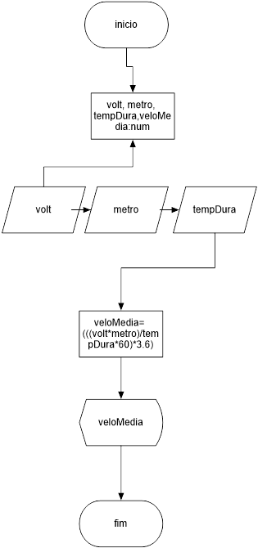

|  |  |  |  |
| --- | --- | --- | --- |
| TESTE DE MESA | | | |
| Medidas | 2 | 50 | 14 |

|  |  |  |
| --- | --- | --- |
| MASSA DE DADOS | | |
| 2 | = | voltas |
| 50 | = | metros |
| 14 | = | mim |
| Result | = | 154 |

Exercício 28

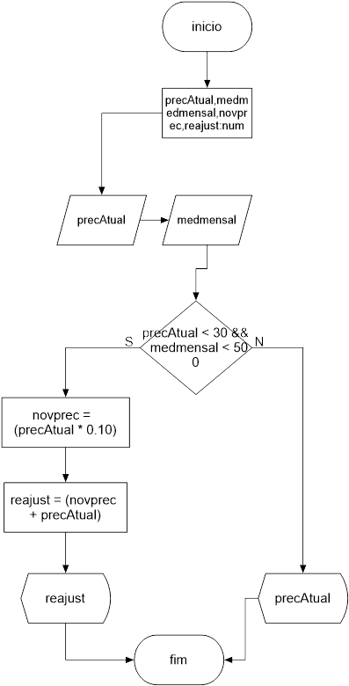

|  |  |  |  |
| --- | --- | --- | --- |
| TESTE DE MESA | | | |
| Valor | 29 e 400 | 31 e 550 |  |

|  |  |  |
| --- | --- | --- |
| MASSA DE DADOS | | |
| 29 e 400 | = | 31 |
| 35 e 550 | = | 35 |

Exercício 29

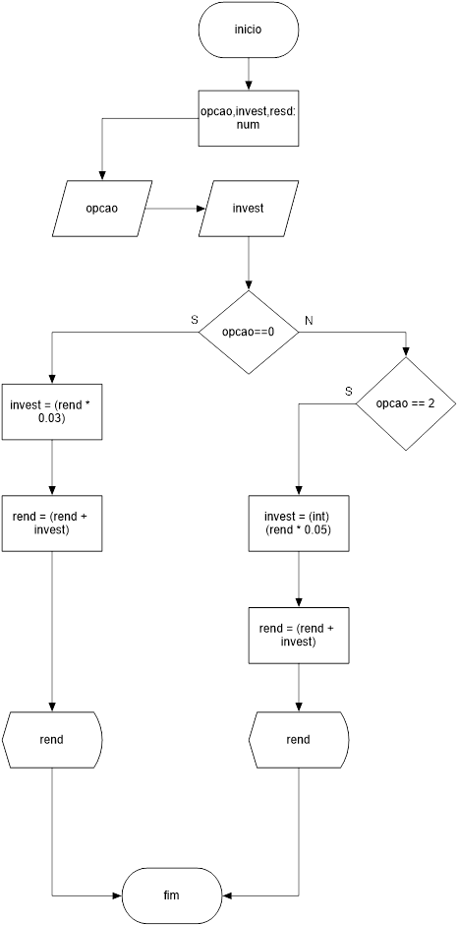

|  |  |  |  |
| --- | --- | --- | --- |
| TESTE DE MESA | | | |
| Valor | 1 e 400 | 2 e 900 |  |

|  |  |  |
| --- | --- | --- |
| MASSA DE DADOS | | |
| 1 e 400 | = | 412 |
| 2 e 900 | = | 945 |

Exercício 30



|  |  |  |  |
| --- | --- | --- | --- |
| TESTE DE MESA | | | |
| Medidas | 2 | 50 | 14 |

|  |  |  |
| --- | --- | --- |
| MASSA DE DADOS | | |
| 2 | = | voltas |
| 50 | = | metros |
| 14 | = | mim |
| Result | = | 154 |

Exercício 31

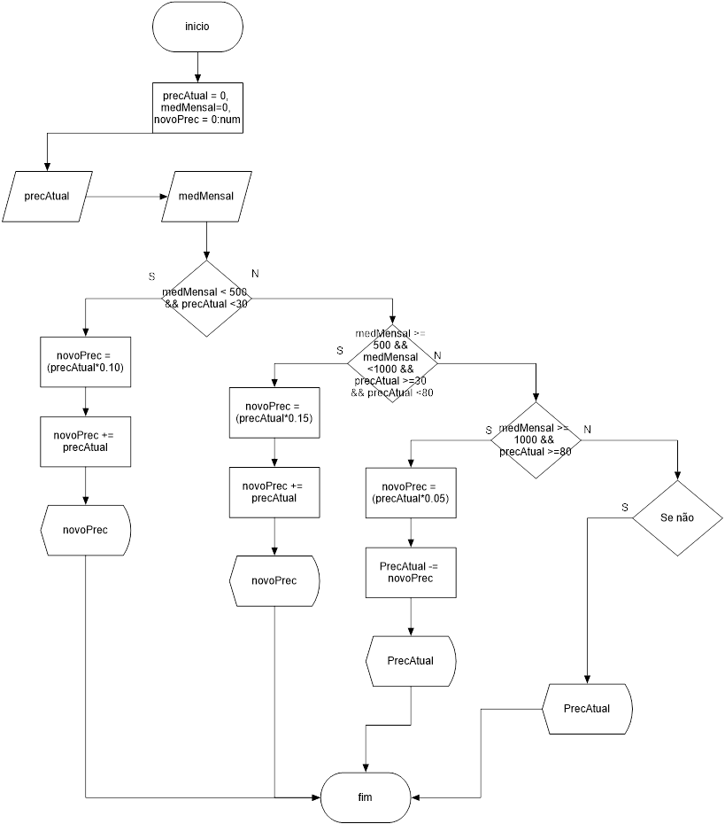

|  |  |  |  |
| --- | --- | --- | --- |
| TESTE DE MESA | | | |
| PrecAtual | 14 | 40 | 90 |
| medMensal | 200 | 510 | 1200 |

|  |  |  |  |
| --- | --- | --- | --- |
| MASSA DE DADOS | | | |
| PrecAtual | 14 | 40 | 90 |
| medMensal | 200 | 510 | 1200 |
| novoPrec | 15,4 | 46 | 85,5 |

Exercício 32

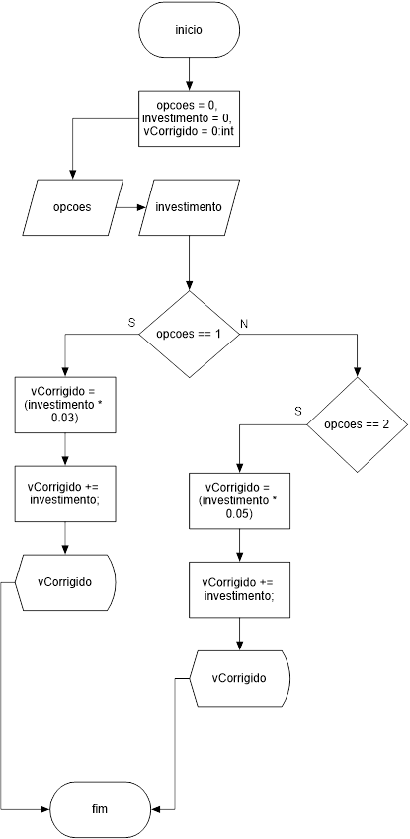

|  |  |  |
| --- | --- | --- |
| TESTE DE MESA | | |
| Opcoes | 1 | 2 |
| Investimento | 200 | 350 |

|  |  |  |
| --- | --- | --- |
| MASSA DE DADOS | | |
| Opcoes | 1 | 2 |
| Investimento | 200 | 350 |
| vCorrigido | 206 | 367.5 |

Exercício 33

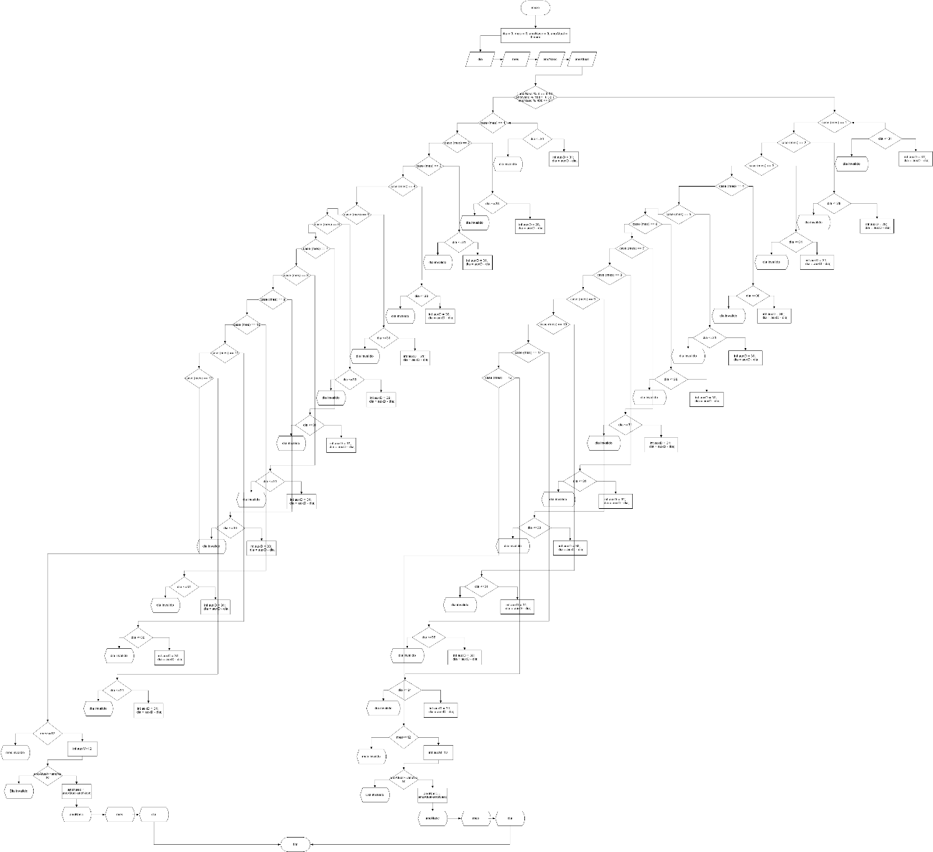

|  |  |  |  |
| --- | --- | --- | --- |
| TESTE DE MESA | | | |
| Dia | 29 | 28 |  |
| Mês | 07 | 02 |  |
| anoNasc | 1997 | 1997 |  |
| anoAtual | 2017 | 2017 |  |

|  |  |  |  |
| --- | --- | --- | --- |
| MASSA DE DADOS | | | |
| Dia | = | 29 | 28 |
| Mês | = | 07 | 02 |
| anoNasc | = | 1997 | 1997 |
| anoAtual | = | 2017 | 2017 |
| AnoNasc | = | 20 | 20 |
| Mês | = | 5 | 10 |
| Dia | = | 31 | 31 |

Exercício 34

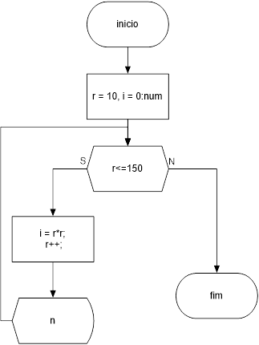

Massa de dados: r= 10

|  |  |  |  |  |
| --- | --- | --- | --- | --- |
| MASSA DE DADOS | | | | |
| r | 10 | 11 | ... | 150 |
| i | 100 | 121 | ... | 22500 |

Exercício 35

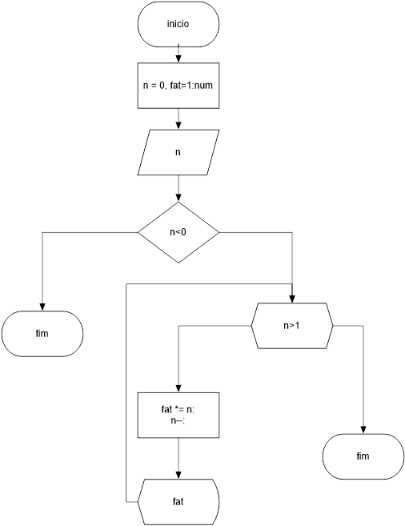

|  |  |  |
| --- | --- | --- |
| TESTE DE MESA | | |
| Números | 5 | -1 |

|  |  |  |  |
| --- | --- | --- | --- |
| MASSA DE DADOS | | |  |
| 5 | 20 | 60 | 120 |
| -1 | - | - | - |

Exercício 36

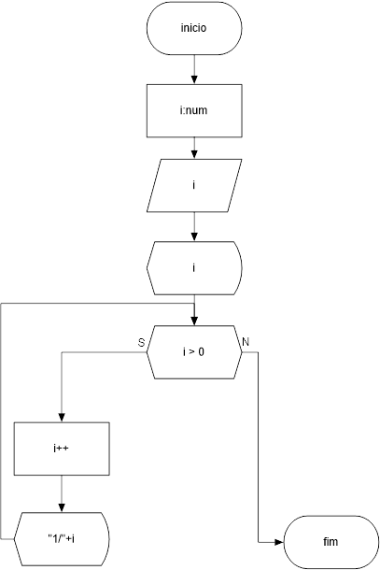

|  |  |
| --- | --- |
| TESTE DE MESA | |
| Números | 2 |

|  |  |  |  |
| --- | --- | --- | --- |
| MASSA DE DADOS | | |  |
| 1 | 1 | 1 | ... |
| - | 2 | 3 | ... |

Exercício 37

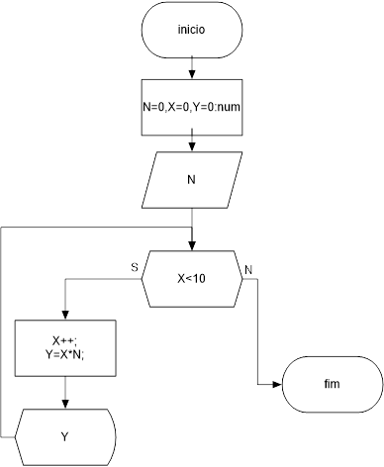

|  |  |  |
| --- | --- | --- |
| TESTE DE MESA | | |
| Números | 5 | - |

|  |  |  |  |  |  |  |  |  |  |
| --- | --- | --- | --- | --- | --- | --- | --- | --- | --- |
| MASSA DE DADOS | | |  |  |  |  |  |  |  |
| 5 | 10 | 15 | 20 | 25 | 30 | 35 | 40 | 45 | 50 |
| - | - | - | - |  |  |  |  |  |  |

Exercício 40

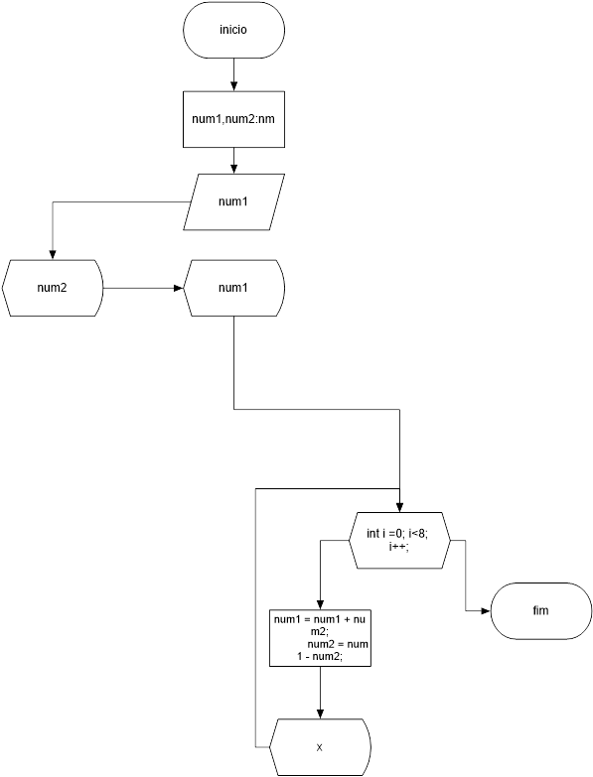

|  |  |  |  |
| --- | --- | --- | --- |
| TESTE DE MESA | | | |
| Números | 1 | 0 | 5 |

|  |  |  |  |  |
| --- | --- | --- | --- | --- |
| MASSA DE DADOS | | | | |
| 1 | - | - | - | - |
| 0 | - | - | - | - |
| 5 | 6 | 7 | ... | 100 |

Exercício 41

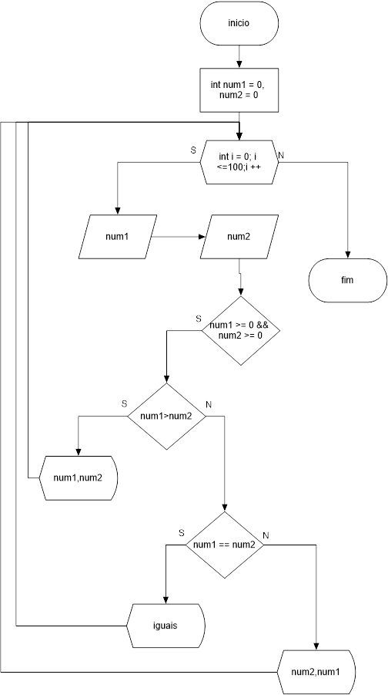

|  |  |  |  |  |
| --- | --- | --- | --- | --- |
| TESTE DE MESA | | | |  |
| Números | 1,2 | 2,2 | 0,0 | 2,1 |

|  |  |  |  |  |  |  |  |  |  |
| --- | --- | --- | --- | --- | --- | --- | --- | --- | --- |
| MASSA DE DADOS | | | | | | | | | |
| 2 | 1 | ... | Iguais | Iguais | ... | ... | ... | 2 | 1 |

Exercício 42

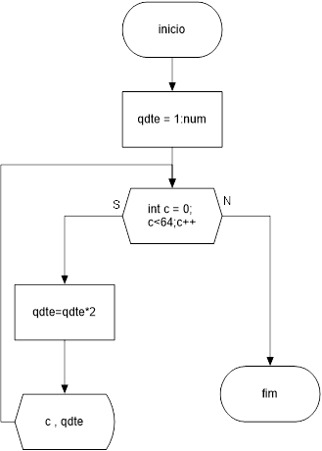

|  |  |  |  |  |  |
| --- | --- | --- | --- | --- | --- |
| MASSA DE DADOS | | | | |  |
| C | 1 | 2 | 3 | ... | 64 |
| qtde | 1 | 2 | 4 | ... | 9,2233... |

Exercício 44

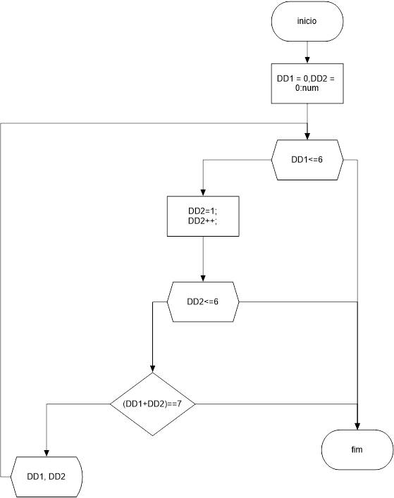

|  |  |  |
| --- | --- | --- |
| MASSA DE DADOS | | |
| 1 | E | 6 |
| 2 | E | 5 |
| 3 | E | 4 |
| 4 | E | 3 |
| 5 | E | 2 |
| 6 | E | 1 |

Exercício 45

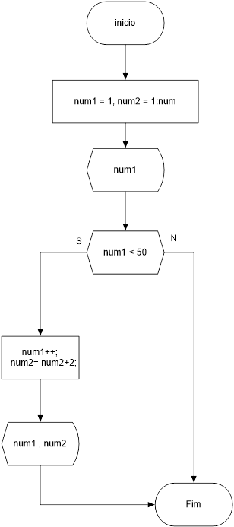

|  |  |  |  |  |  |
| --- | --- | --- | --- | --- | --- |
| MASSA DE DADOS | | | | |  |
| 1 | 2 | 3 | 4 | ... | 50 |
| - | 3 | 5 | 7 | ... | 99 |

Exercicio 46

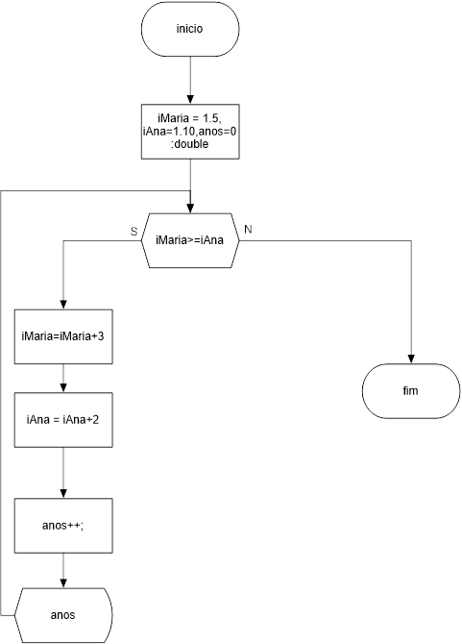

Exercício 47

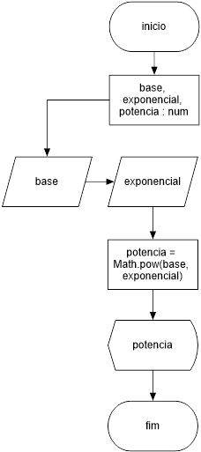

|  |  |
| --- | --- |
| TESTE DE MESA | |
| Expoente | 2 |
| Base | 5 |

|  |
| --- |
| MASSA DE DADOS |
| 25 |

Exercício 48

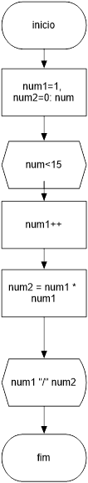

|  |  |
| --- | --- |
| TESTE DE MESA | |
| Num1 | 1 |
| Num2 | 0 |

|  |  |  |  |  |
| --- | --- | --- | --- | --- |
| MASSA DE DADOS | | | | |
| 1 | 2 | 3 | ... | 15 |
| - | 4 | 9 | ... | 225 |

Modularizados: Procedurais

Exercicio 16

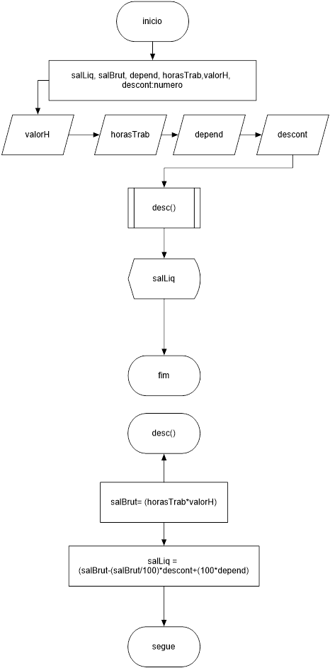

|  |  |
| --- | --- |
| TESTE DE MESA | |
| HT | 5 |
| QT | 10 |
| DP | 2 |
| Desc | 3 |

|  |  |  |
| --- | --- | --- |
| MASSA DE DADOS | | |
| HT | = | 5 |
| QT | = | 10 |
| DP | = | 2 |
| Desc | = | 3 |
| SalLiq | = | 250 |

Exercicio 17

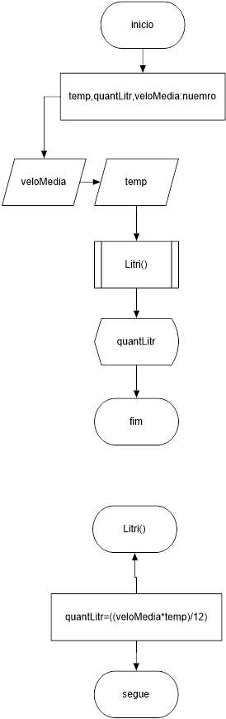

|  |  |
| --- | --- |
| TESTE DE MESA | |
| VeloMedia | 60 |
| Temp | 70 |

|  |  |  |
| --- | --- | --- |
| MASSA DE DADOS | | |
| VeloMedia | = | 60 |
| Temp | = | 70 |
| quantLitr | = | 350 |

Exercício 18

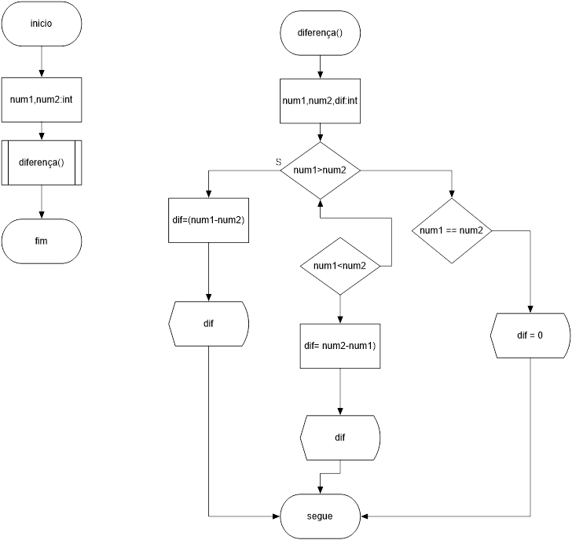

|  |  |  |  |
| --- | --- | --- | --- |
| TESTE DE MESA | | | |
| Números | 5 e 2 | 3 e 9 | 5 e 5 |

|  |  |  |
| --- | --- | --- |
| MASSA DE DADOS | | |
| 5 e 2 | = | 3 |
| 3 e 9 | = | 6 |
| 5 e 5 | = | 0 |

Exercício 19

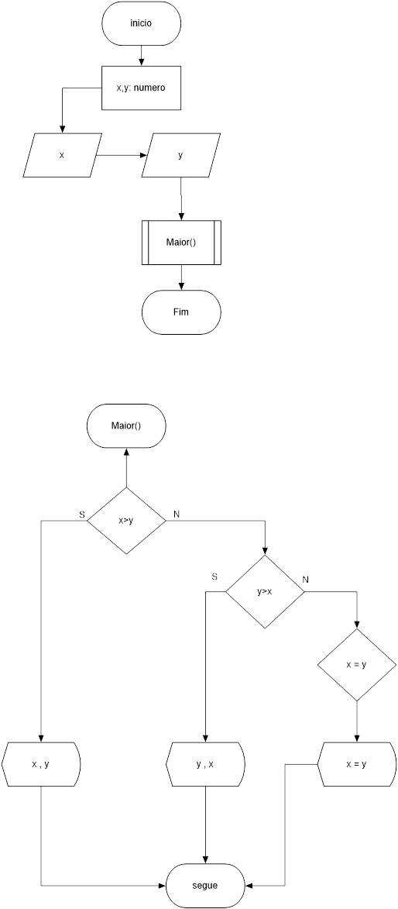

|  |  |  |  |
| --- | --- | --- | --- |
| TESTE DE MESA | | | |
| Números | 5 e 2 | 3 e 9 | 5 e 5 |

|  |  |  |
| --- | --- | --- |
| MASSA DE DADOS | | |
| 5 e 2 | = | 5 e 2 |
| 3 e 9 | = | 9 e 3 |
| 5 e 5 | = | 5 = 5 |

Exercício 20

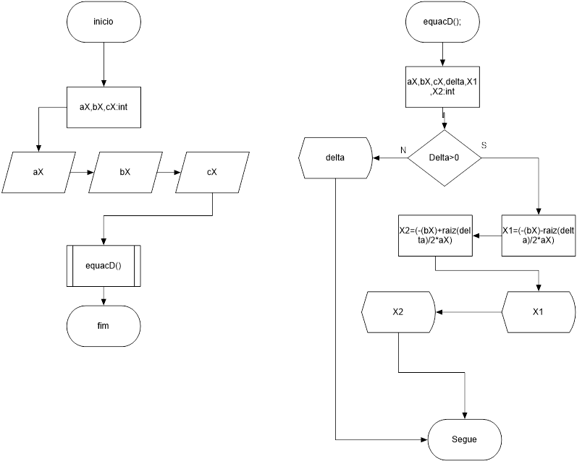

|  |  |  |
| --- | --- | --- |
| TESTE DE MESA | | |
| Números | 1,-4,-5 | 4,8,6 |

|  |  |  |
| --- | --- | --- |
| MASSA DE DADOS | | |
|  | X1 | X2 |
| 1,-4,-5 | -10 | 5 |
| 4,8,6 | Indefinido | Indefinido |

Exercício 21

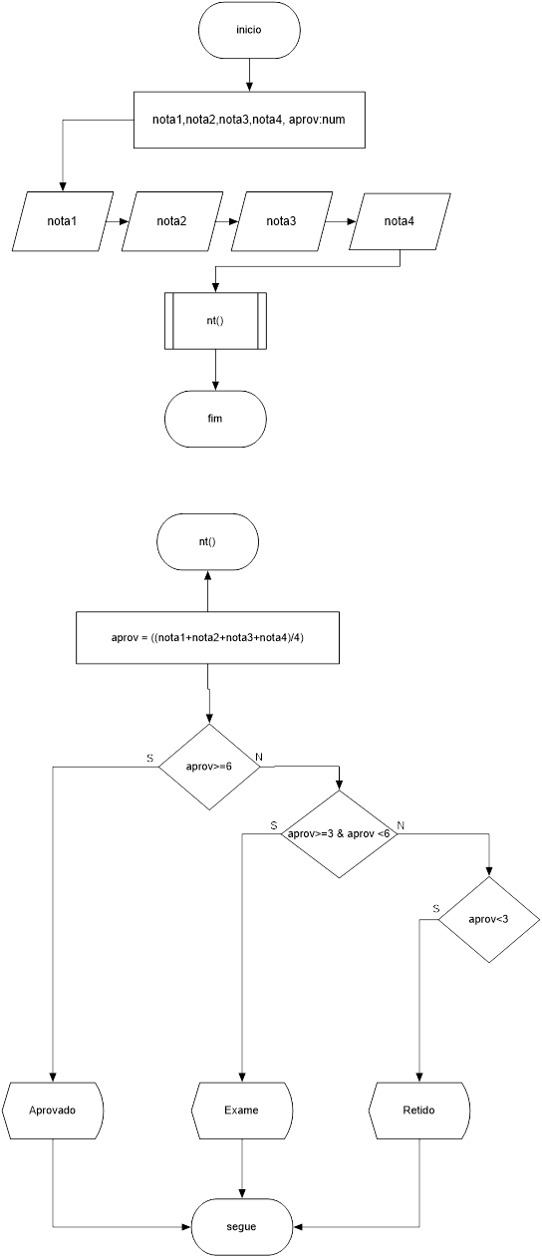

|  |  |  |  |
| --- | --- | --- | --- |
| TESTE DE MESA | | | |
| Notas | 7 | 4,5 | 5 e 5 |

|  |  |  |
| --- | --- | --- |
| MASSA DE DADOS | | |
| 7 | = | Aprovado |
| 4,5 | = | Exame |
| 2,2 | = | Retido |

Exercício 22

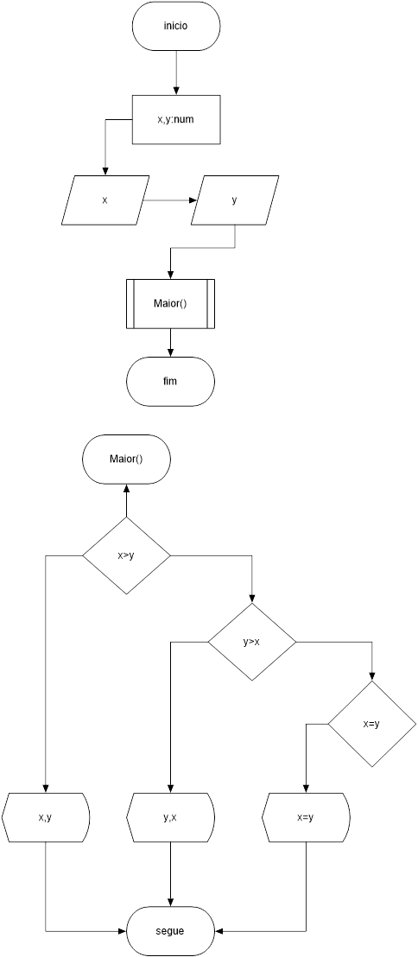

|  |  |  |  |
| --- | --- | --- | --- |
| TESTE DE MESA | | | |
| Notas | 5,2 | 4,5 | 5 e 5 |

|  |  |  |
| --- | --- | --- |
| MASSA DE DADOS | | |
| 5,2 | 5 | 2 |
| 2,9 | 9 | 2 |
| 5,5 | 5 | 5 |

Exercicio 23

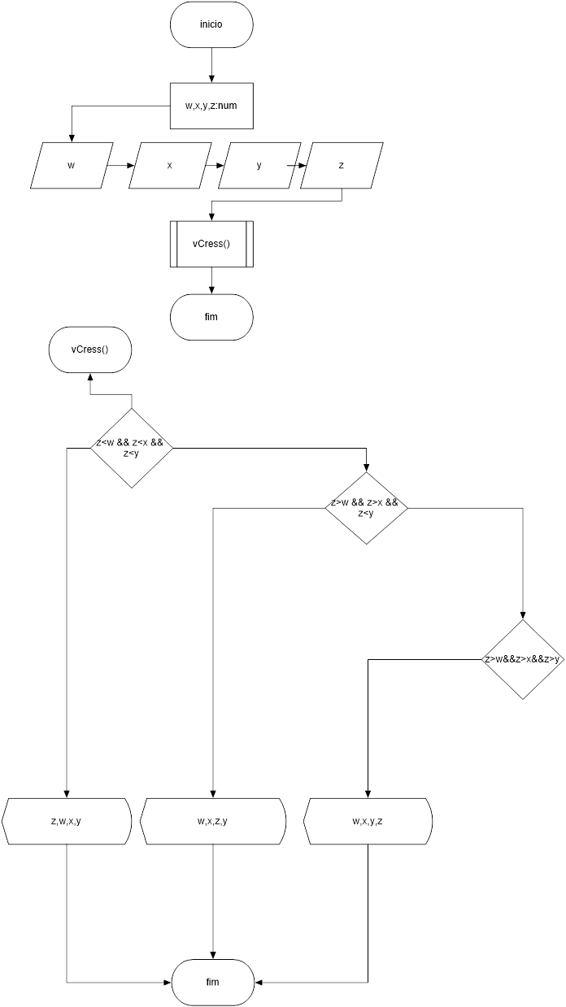

|  |  |  |  |  |
| --- | --- | --- | --- | --- |
| TESTE DE MESA | | | | |
| Posições | W | X | Y | Z |
|  | 2 | 3 | 4 | 1 |
|  | 1 | 2 | 3 | 4 |
|  | 1 | 2 | 3 | 6 |

|  |  |  |  |
| --- | --- | --- | --- |
| MASSA DE DADOS | | | |
| 1 | 2 | 3 | 4 |
| 1 | 2 | 3 | 4 |
| 1 | 2 | 3 | 6 |

Exercicio 24

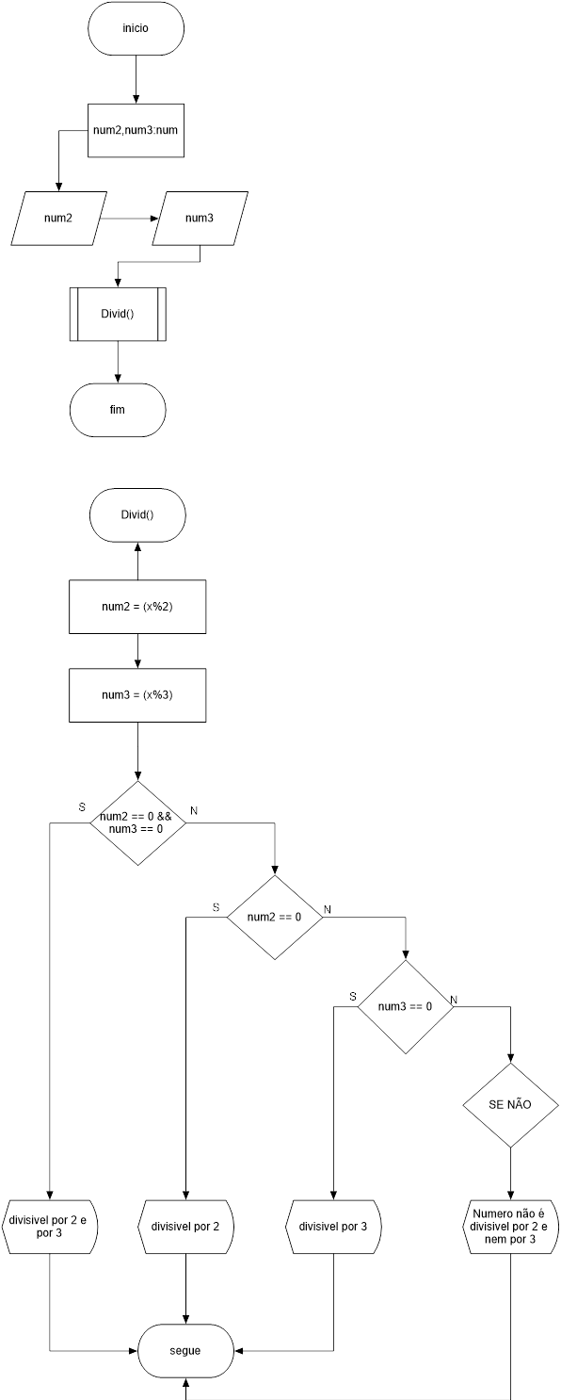

|  |  |  |  |  |
| --- | --- | --- | --- | --- |
| TESTE DE MESA | | | | |
| Números | 6 | 4 | 9 | 7 |

|  |  |  |
| --- | --- | --- |
| MASSA DE DADOS | | |
| 6 | = | É divisível por 2 e por 3 |
| 4 | = | É divisível por 2 |
| 9 | = | É divisível por 3 |
| 7 | = | Não é divisível por 2 e por 3 |

Exercício 25

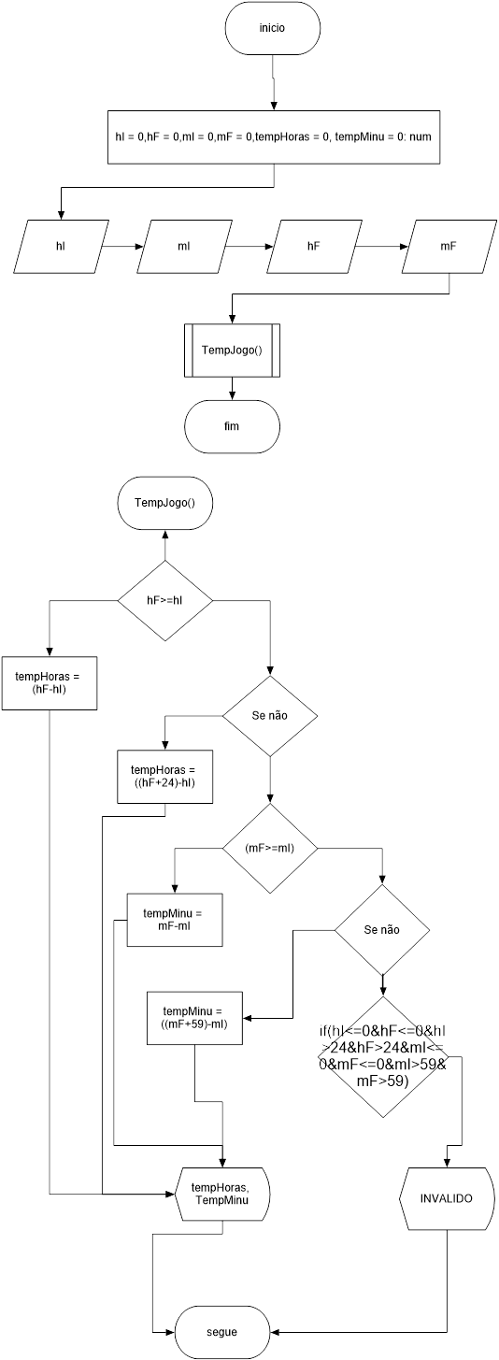

|  |  |  |  |
| --- | --- | --- | --- |
| TESTE DE MESA | | | |
| hI | 2 | 0 |  |
| mI | 20 | 0 |  |
| hF | 3 | 0 |  |
| mF | 50 | 0 |  |

|  |  |  |
| --- | --- | --- |
| MASSA DE DADOS | | |
| hI | 2 | 0 |
| mI | 20 | 0 |
| hF | 3 | 0 |
| mF | 50 | 0 |
| TempHoras | 1 | Invalido |
| TempMinutos | 30 | Invalido |

Exercício 26

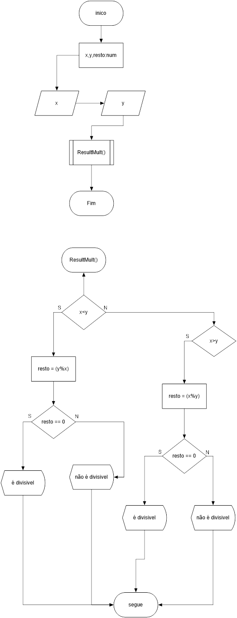

|  |  |  |  |
| --- | --- | --- | --- |
| TESTE DE MESA | | | |
| X | 10 | 5 |  |
| y | 2 | 2 |  |

|  |  |  |
| --- | --- | --- |
| MASSA DE DADOS | | |
| X | 10 | 5 |
| y | 2 | 2 |
| Resto | É divisível | Não é divisivel |

Exercício 27

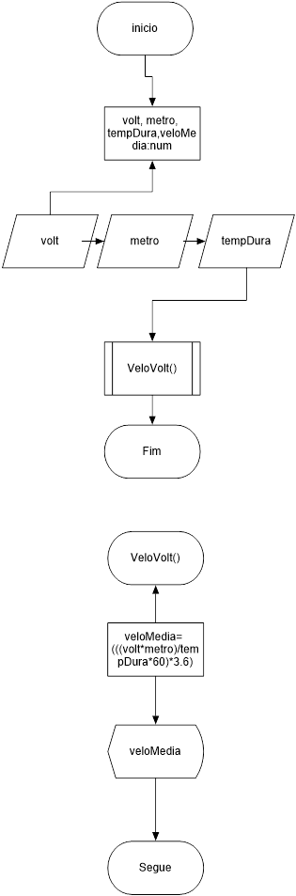

|  |  |  |  |
| --- | --- | --- | --- |
| TESTE DE MESA | | | |
| Medidas | 2 | 50 | 14 |

|  |  |  |
| --- | --- | --- |
| MASSA DE DADOS | | |
| 2 | = | voltas |
| 50 | = | metros |
| 14 | = | mim |
| Result | = | 154 |

Exercício 28

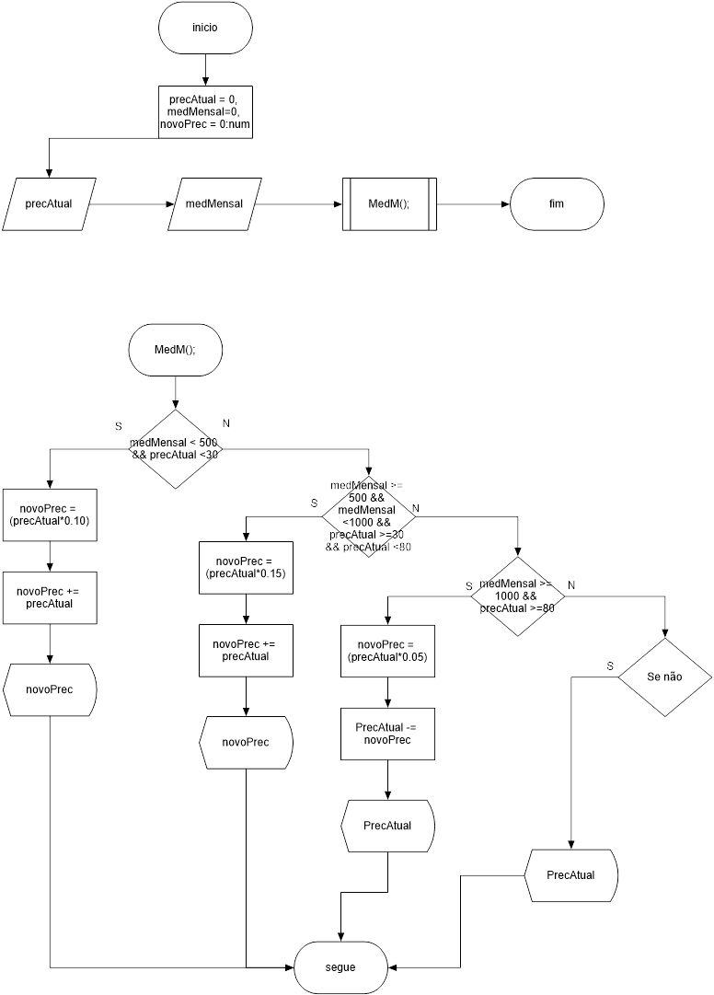

|  |  |  |  |
| --- | --- | --- | --- |
| TESTE DE MESA | | | |
| PrecAtual | 14 | 40 | 90 |
| medMensal | 200 | 510 | 1200 |

|  |  |  |  |
| --- | --- | --- | --- |
| MASSA DE DADOS | | | |
| PrecAtual | 14 | 40 | 90 |
| medMensal | 200 | 510 | 1200 |
| novoPrec | 15,4 | 46 | 85,5 |

Exercício 29

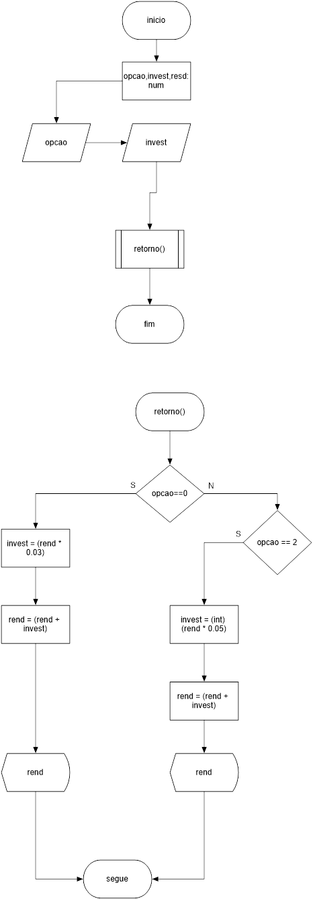

|  |  |  |  |
| --- | --- | --- | --- |
| TESTE DE MESA | | | |
| Valor | 1 e 400 | 2 e 900 |  |

|  |  |  |
| --- | --- | --- |
| MASSA DE DADOS | | |
| 1 e 400 | = | 412 |
| 2 e 900 | = | 945 |

Modularizados: Com funções

Exercício 30

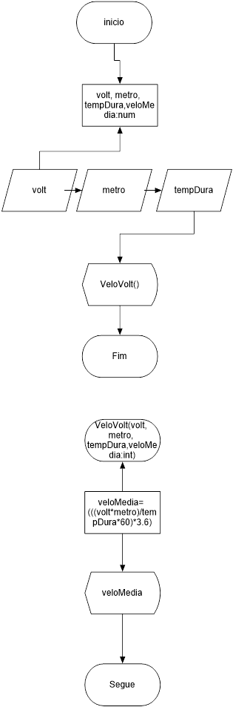

|  |  |  |  |
| --- | --- | --- | --- |
| TESTE DE MESA | | | |
| Medidas | 2 | 50 | 14 |

|  |  |  |
| --- | --- | --- |
| MASSA DE DADOS | | |
| 2 | = | voltas |
| 50 | = | metros |
| 14 | = | mim |
| Result | = | 154 |

Exercício 31

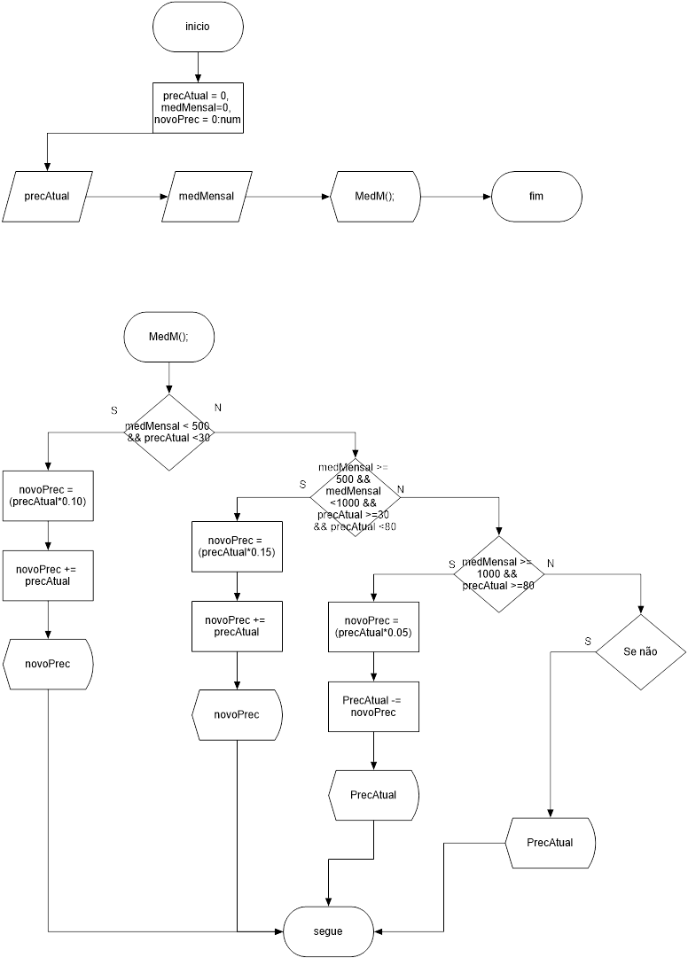

|  |  |  |  |
| --- | --- | --- | --- |
| TESTE DE MESA | | | |
| PrecAtual | 14 | 40 | 90 |
| medMensal | 200 | 510 | 1200 |

|  |  |  |  |
| --- | --- | --- | --- |
| MASSA DE DADOS | | | |
| PrecAtual | 14 | 40 | 90 |
| medMensal | 200 | 510 | 1200 |
| novoPrec | 15,4 | 46 | 85,5 |

Exercício 32

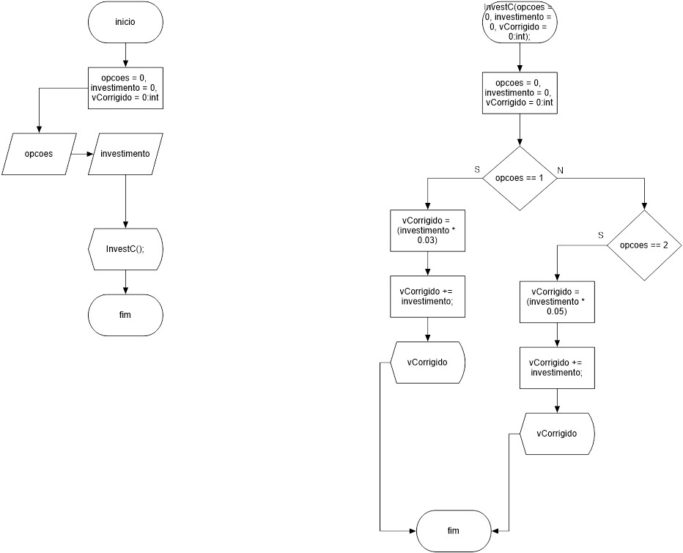

|  |  |  |
| --- | --- | --- |
| TESTE DE MESA | | |
| Opcoes | 1 | 2 |
| Investimento | 200 | 350 |

|  |  |  |
| --- | --- | --- |
| MASSA DE DADOS | | |
| Opcoes | 1 | 2 |
| Investimento | 200 | 350 |
| vCorrigido | 206 | 367.5 |

Exercício 33

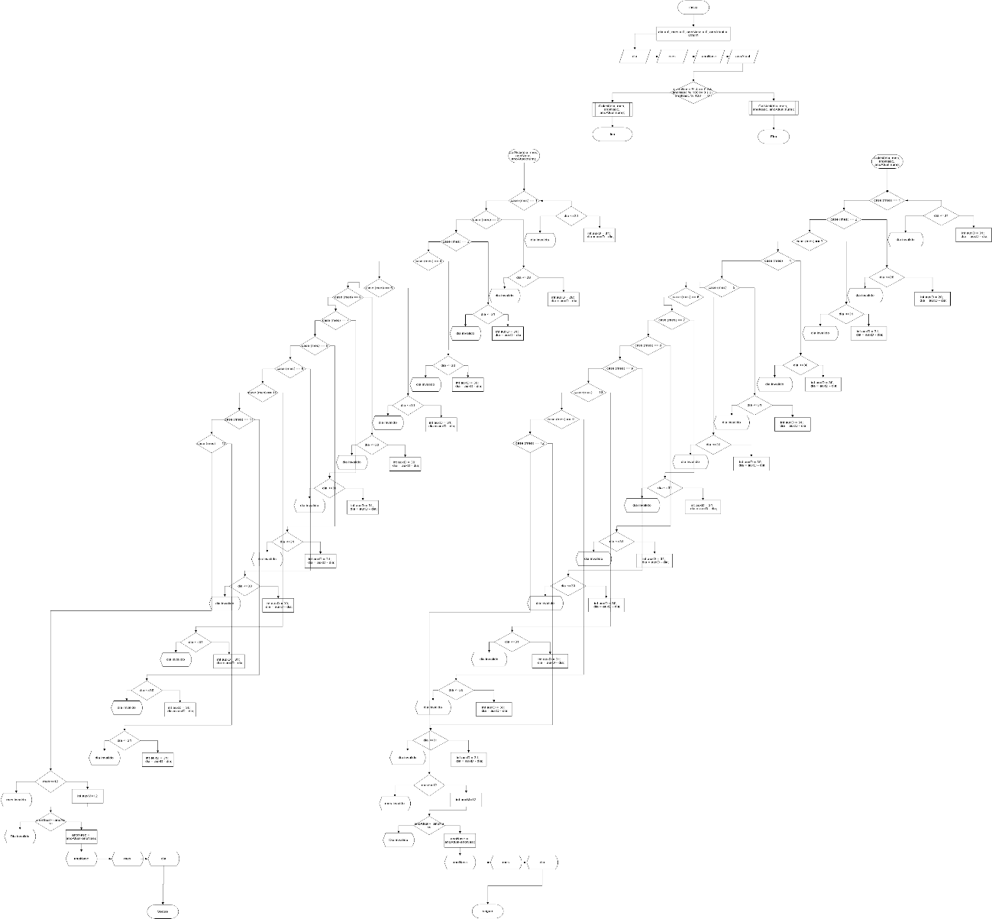

|  |  |  |  |
| --- | --- | --- | --- |
| TESTE DE MESA | | | |
| Dia | 29 | 28 |  |
| Mês | 07 | 02 |  |
| anoNasc | 1997 | 1997 |  |
| anoAtual | 2017 | 2017 |  |

|  |  |  |  |
| --- | --- | --- | --- |
| MASSA DE DADOS | | | |
| Dia | = | 29 | 28 |
| Mês | = | 07 | 02 |
| anoNasc | = | 1997 | 1997 |
| anoAtual | = | 2017 | 2017 |
| AnoNasc | = | 20 | 20 |
| Mês | = | 5 | 10 |
| Dia | = | 31 | 31 |

Exercício 34

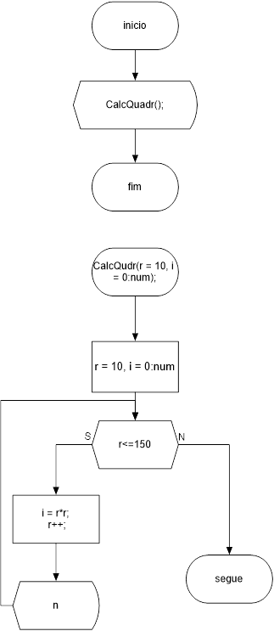

|  |  |  |  |  |
| --- | --- | --- | --- | --- |
| MASSA DE DADOS | | | | |
| r | 10 | 11 | ... | 150 |
| i | 100 | 121 | ... | 22500 |

Exercício 35

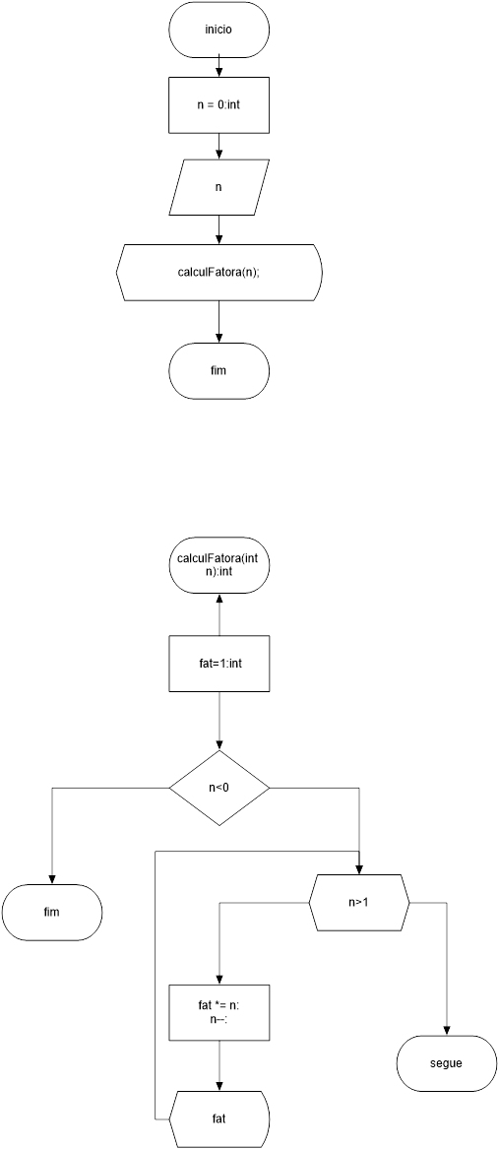

|  |  |  |
| --- | --- | --- |
| TESTE DE MESA | | |
| Números | 5 | -1 |

|  |  |  |  |
| --- | --- | --- | --- |
| MASSA DE DADOS | | |  |
| 5 | 20 | 60 | 120 |
| -1 | - | - | - |

Exercício 36

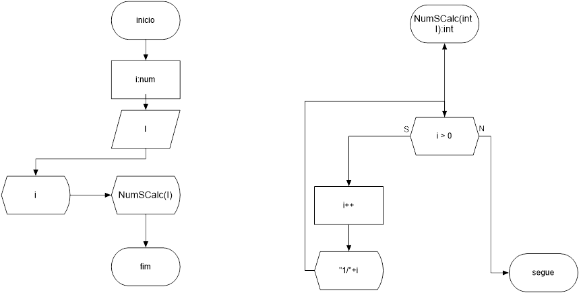

|  |  |
| --- | --- |
| TESTE DE MESA | |
| Números | 2 |

|  |  |  |  |
| --- | --- | --- | --- |
| MASSA DE DADOS | | |  |
| 1 | 1 | 1 | ... |
| - | 2 | 3 | ... |

Exercício 37

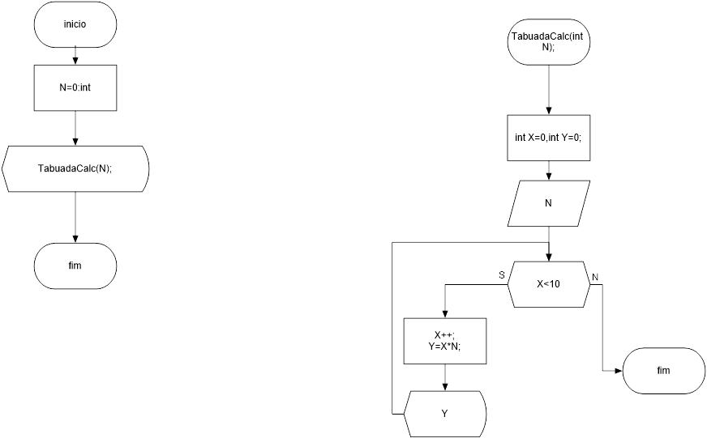

|  |  |  |
| --- | --- | --- |
| TESTE DE MESA | | |
| Números | 5 | - |

|  |  |  |  |  |  |  |  |  |  |
| --- | --- | --- | --- | --- | --- | --- | --- | --- | --- |
| MASSA DE DADOS | | |  |  |  |  |  |  |  |
| 5 | 10 | 15 | 20 | 25 | 30 | 35 | 40 | 45 | 50 |
| - | - | - | - |  |  |  |  |  |  |

Exercício 40

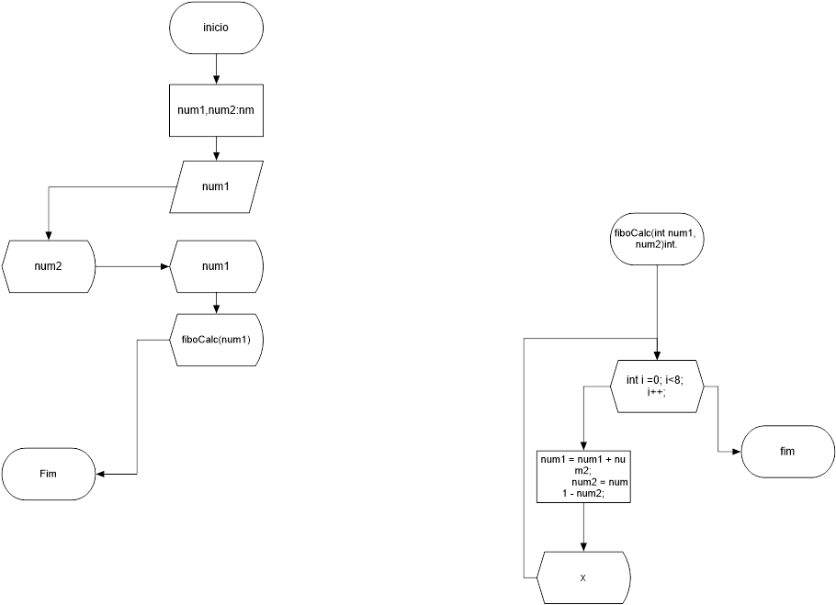

|  |  |  |  |
| --- | --- | --- | --- |
| TESTE DE MESA | | | |
| Números | 1 | 0 | 5 |

|  |  |  |  |  |
| --- | --- | --- | --- | --- |
| MASSA DE DADOS | | | | |
| 1 | - | - | - | - |
| 0 | - | - | - | - |
| 5 | 6 | 7 | ... | 100 |

Exercício 41

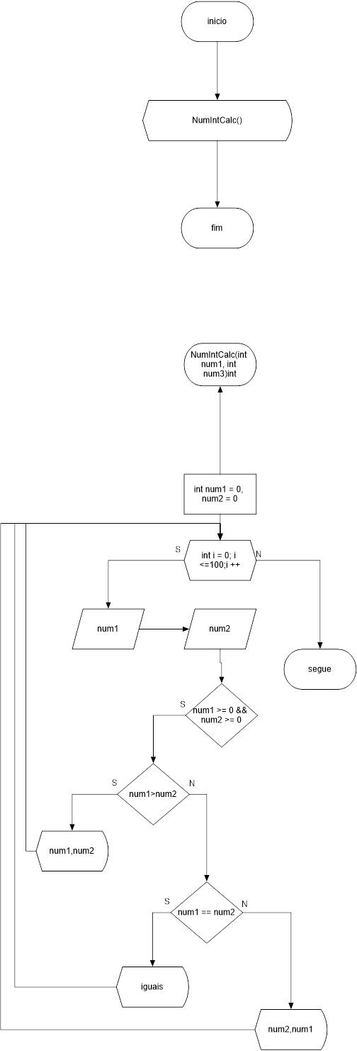

|  |  |  |  |  |
| --- | --- | --- | --- | --- |
| TESTE DE MESA | | | |  |
| Números | 1,2 | 2,2 | 0,0 | 2,1 |

|  |  |  |  |  |  |  |  |  |  |
| --- | --- | --- | --- | --- | --- | --- | --- | --- | --- |
| MASSA DE DADOS | | | | | | | | | |
| 2 | 1 | ... | Iguais | Iguais | ... | ... | ... | 2 | 1 |

Exercício 42

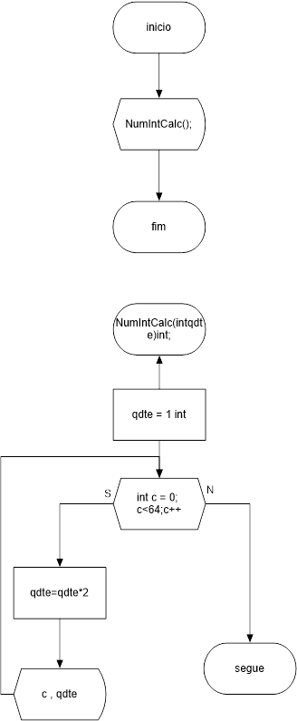

|  |  |  |  |  |  |
| --- | --- | --- | --- | --- | --- |
| MASSA DE DADOS | | | | |  |
| C | 1 | 2 | 3 | ... | 64 |
| qtde | 1 | 2 | 4 | ... | 9,2233... |

Exercício 44

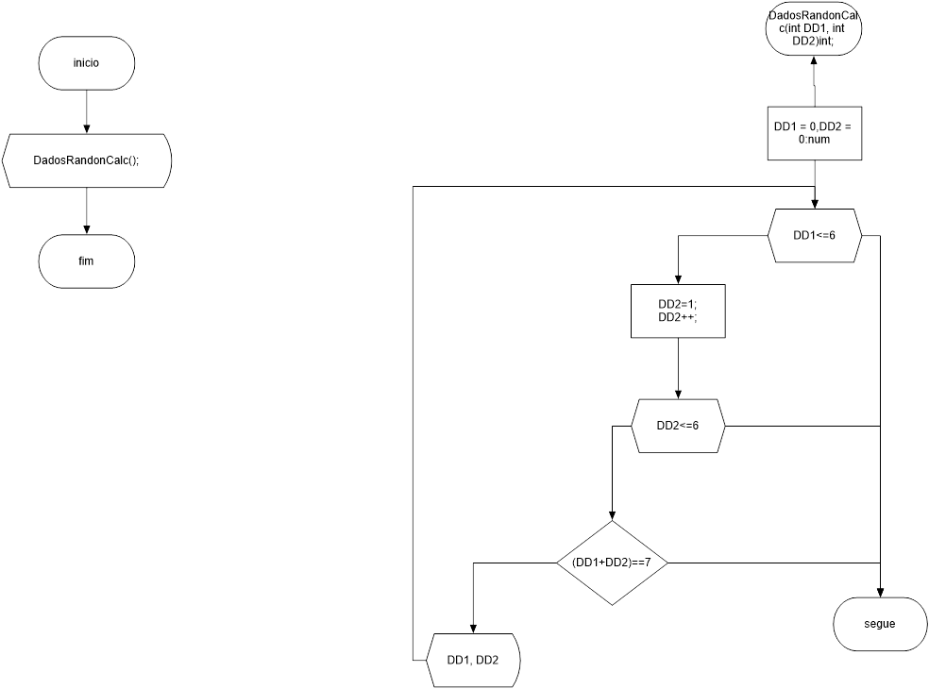

|  |  |  |
| --- | --- | --- |
| MASSA DE DADOS | | |
| 1 | E | 6 |
| 2 | E | 5 |
| 3 | E | 4 |
| 4 | E | 3 |
| 5 | E | 2 |
| 6 | E | 1 |

Exercício 45

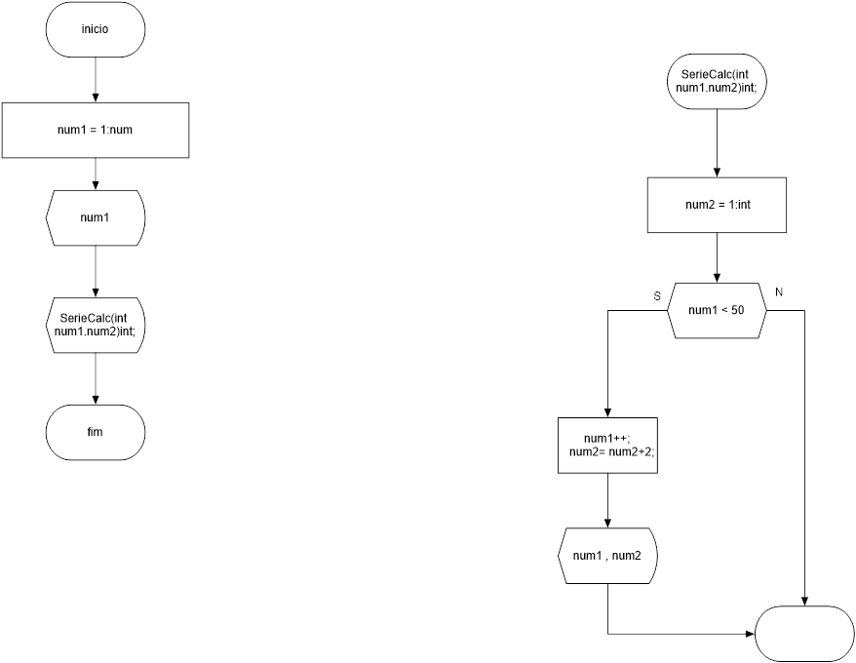

segue

|  |  |  |  |  |  |
| --- | --- | --- | --- | --- | --- |
| MASSA DE DADOS | | | | |  |
| 1 | 2 | 3 | 4 | ... | 50 |
| - | 3 | 5 | 7 | ... | 99 |